Filed by Computer Sciences Corporation

Pursuant to Rule 425 under the Securities Act of 1933, as amended

and deemed filed pursuant to Rule 14a-12

under the Securities Exchange Act of 1934, as amended

Subject Company: Computer Sciences Corporation

(Commission File No. 1-4850)


Two months ago we launched a comprehensive Organization Design & Selection (OD&S) process to select the leadership team for our new company. We assigned Heidrick & Struggles, a leading global talent advisory firm (and trusted partner to both CSC and HPE), to conduct a fair and thorough assessment across both organizations. The leadership selections being announced today draw from both companies, and leaders have been chosen based on criteria such as experience, performance, leadership qualities and cultural fit.

Today’s announcement includes all L2 leaders - those who will report directly to Mike Lawrie, who will be the new company’s chairman, president and CEO - as well as regional general managers, global industry general managers, global offering leaders and other selected corporate roles.

This is an important milestone in establishing our new company. We extend our great thanks and appreciation to the leaders from both CSC and HPE ES for participating in the selection process, and for their commitment to the success of their organizations and our proposed combination.

SUPPORTING NEWCO VISION, MISSION, AND OPERATING MODEL

When the merger transaction closes, NewCo will become the world’s leading independent, end-to-end IT services company, focused on guiding clients on their digital transformation journeys.

As we have communicated previously, the merger is the logical next step in the transformation journeys of both CSC and HPE ES. Our new company will be uniquely positioned to lead digital transformations - creating greater value for clients, partners and shareholders, and presenting new growth opportunities for our people.

To achieve this goal, we have developed an operating model built around three primary motions: Build, Sell and Deliver.

- We will Build solutions with our partners that answer key market needs and lead digital transformations.

- We will Sell these solutions to customer and prospects - often with our partners - by anticipating and responding to their changing demands.

- And we will Deliver these solutions in an exceptional way, on-time and on-budget.

The leadership structure being announced today is set up to support the Build-Sell-Deliver operating model. It also reflects the requirements of our go-forward global footprint, industry expertise, and corporate services structure.

- Build will consist of nine global offerings, including Industry Solutions (which will be aligned to their respective global industries where applicable).
- Sell will be led by Mike Nefkens as EVP & GM, Regions & Industries. It will be the company’s primary P&L and will organized into six regions, three vertically integrated global industries and U.S. Public Sector (USPS).
  - The Sales Organization will be led by Larry Stack, reporting to Mike Nefkens; the regional sales leaders reporting to Larry will be announced in the coming weeks.
- Deliver, which will be led by Steve Hilton, will be organized by six regional account-specific delivery teams, a network of eight offering delivery and transformation teams, and commercial and restricted delivery centers.

The Build, Sell and Deliver groups will come together seamlessly to enable us to best support our customers and prospects.

THE NEWCO LEADERSHIP TEAM

Below is information on each position and individual leader. The list shows L2 appointments along with Regional, Global Industry and Offering general managers and strategic corporate roles. These slides show the reporting structure that will take effect upon close of our proposed merger.

Mike Lawrie Direct Reports

- Mike Nefkens - Executive Vice President & GM, Regions & Industries

Mr. Nefkens, HPE ES EVP & GM, will serve as NewCo’s EVP & GM to set the vision and go-to-market strategy for the Regions and Industries. He will lead sales and business development initiatives across regions/accounts, the core industries and U.S. Public Sector business, along with other strategic growth initiatives. He will partner with the Build leaders to develop next generation offerings.

- Stephen Hilton - Executive Vice President, Deliver

Currently CSC Executive VP & GM, Global Infrastructure Services, Mr. Hilton as NewCo EVP will serve as global head of the Deliver organization. He will focus on the successful execution and ongoing performance improvement of the global delivery organization and operating model, including account-focused delivery, offering delivery and transformation, as well as the global delivery network and the delivery management functions that support operations.

- Paul Saleh - Executive Vice President and Chief Financial Officer

Currently CSC’s EVP & CFO, Mr. Saleh will continue in that role for NewCo. He will serve as financial counsel to senior leadership and the Board of Directors and will be responsible for the worldwide finance organization.
- Bill Deckelman - Executive Vice President, General Counsel & Secretary

Mr. Deckelman is currently CSC EVP & General Counsel. As NewCo EVP, General Counsel & Secretary, he will serve as principal counsel and advisor to senior leadership and the Board of Directors, with global responsibility for all legal, privacy, contracting, M&A, litigation, and compliance activities, as well as government and regulatory affairs.

- Jo Mason - Executive Vice President and Chief Human Resource Officer

Ms. Mason is CSC Chief Human Resources Officer (CHRO). As EVP and CHRO for NewCo, she will lead all aspects of human resources, including talent recruitment and retention, policy, benefits and compensation, workforce development and organization effectiveness, staffing and training, along with global inclusion and diversity.

- Sreekanth Arimanithaya - Senior Vice President, Integrated Workforce Management and India Co-Lead

Mr. Arimanithaya, CSC Managing Director, India & Global Head of Workforce Management, will become NewCo SVP, Integrated Workforce Management & India Co-Lead, with responsibility for global workforce planning and optimization, strategic & operational demand management, talent recruitment and training, skill management and development, and diversity and inclusion

- Gary Stockman - Senior Vice President, Chief Marketing & Communications Officer

Mr. Stockman will continue in his role for NewCo, leading the global, integrated marketing communications team and advancing the company’s brand, value proposition and competitive position across the globe with critical clients, influencers and stakeholders.
- Dan Hushon - Senior Vice President, Chief Technology Officer

Mr. Hushon is currently CSC CTO and VP & GM, Cybersecurity. As SVP & CTO for NewCo, he will be responsible for driving innovation strategy and growth for the company’s solutions and for ensuring technology excellence. He will define NewCo’s long-term technology strategy and vision, and will advocate for that vision with customers.

- Erich Windmuller - Vice President, Chief Information Officer

Mr. Windmuller, CSC Chief Information Officer, as NewCo VP & CIO will oversee the global strategy and management of all of the company's IT assets that support employees and help drive the company’s strategic priorities.
- Eric Harmon - Executive Vice President, Operations & Integration

Mr. Harmon, HPE SVP &GM, Global Practices and Emerging Business, as NewCo EVP, Operations & Integration will lead the post-merger Integration Management Office to ensure a successful integration. He will also oversee NewCo’s high-growth offerings, as well as the Global Solutioning and Commercial Functions that enable future NewCo offerings.

- Jim Smith - Executive Vice President, Customer Advocacy and Joint Ventures

Currently CSC EVP & GM, Global Business Services, Mr. Smith - in this new leadership role - will advocate on behalf of customers and drive strategic customer initiatives, satisfaction, retention and competitive differentiation. He will also oversee business activities related to the company’s joint ventures, including CeleritiFinTech.

Offering General Managers (Reporting to Mike Lawrie)

Offering general managers are accountable for the growth and profitability of an offering family. They will lead key go-to-market plays centered in the offering family but dependent on other families; drive disciplined execution across offering family build, sell, and deliver functions; and interlock with regional and industry leaders. They will also build and evolve market competitive offerings together with our partners; play an active role in client, partner and analyst leadership; and lead the development of collateral and training for sales and delivery success.

- Eugene O’Callaghan - Senior Vice President and General Manager, Cloud, Workload Platforms & ITO

Mr. O’Callaghan, HPE ES VP & GM for Workload & Cloud, will serve as NewCo SVP & GM for Cloud, Workload Platforms & ITO offering that integrates workload migration, hybrid cloud enablement, storage & compute platform, and network solutions/services.

- Howard Hughes - Senior Vice President and General Manager, Workplace & Mobility

Mr. Hughes, HPE ES SVP, Global Client Transformations, will serve as NewCo SVP & GM for the Workplace & Mobility offering, focused on end user services, virtual desktop services, mobile device management, productivity applications and trusted information services.
- Mike Klaus - Senior Vice President and General Manager, Application Services

Mr. Klaus, HPE ES SVP & General Manager, Global Applications Services and Program Excellence Practice, will serve as NewCo SVP & GM, Application Services offering, focused on application development, application management, and testing services.
- Troy Richardson - Senior Vice President and General Manager, Enterprise & Cloud Apps

Mr. Richardson, CSC GM, as NewCo SVP & GM will oversee the Enterprise & Cloud Apps offering, focused on alliance-driven enterprise solutions and next generation cloud applications, as well as cloud native applications.
- Carlos Lopez-Abadia - Vice President and General Manager, Consulting

Mr. Lopez-Abadia, CSC VP & GM, Global Consulting, as NewCo VP & GM will oversee Consulting that will cover IT strategy and risk and digital transformation advisory services, including strategic partnerships in the consulting domain.
- Mahesh Shah - Vice President and General Manager, Business Process Outsourcing

Mr. Shah, HPE GM & VP, Acquisition & Divestiture IT Consulting Services, as NewCo VP & GM will lead the global business process outsourcing business - both the current portfolio of service offerings, as well as next generation business process services.

Regional Leadership (Reporting to Mike Nefkens)

Regional leaders will be responsible for driving NewCo’s P&L, growth, operations, and overall success in the region by leading the go-to-market teams and driving the local execution of the company’s strategy.

- Kevin Jones - Senior Vice President and General Manager, Americas

Mr. Jones, HPE ES SVP & GM, Americas, as NewCo SVP and GM will lead the Americas Region, which will include Argentina, Brazil, Canada, Chile, Colombia, Mexico, Peru and the United States.
- Nick Wilson - Senior Vice President and General Manager, UK&I

Mr. Wilson, HPE Managing Director, South Pacific, as NewCo’s SVP & GM will lead the UK&I Region, which will include the United Kingdom, Ireland and Israel.
- Michael Eberhardt - Vice President and General Manager, Central and Northern Europe

Mr. Eberhardt, HPE ES VP and GM, Central Cluster, as NewCo VP and GM will lead the Central and Northern Europe (CNE) Region, which will include Austria, Bulgaria, Switzerland, Czech Republic, Germany, Hungary, Poland, Romania, Slovakia, Turkey, Denmark, Finland, Norway, Sweden and the Netherlands.

- Pierre Bruno - Vice President and General Manager, Southern Europe

Mr. Bruno, CSC VP & GM, South & West region, and President of CSC France, will become NewCo VP & GM leading the Southern Europe Region, which will include Spain, France, Portugal, Italy, Malta, Belgium and Luxembourg.
- Maruf Majed - Vice President and General Manager, Asia, Middle East & Africa

Mr. Majed, CSC VP & GM for the Asia, Middle East & Africa (AMEA) region, will become VP & GM for NewCo’s AMEA Region, which includes China, Hong Kong, Indonesia, India, Japan, Korea, Malaysia, Philippines, Singapore, Thailand, Taiwan, Vietnam, the Middle East and Africa.

- Seelan Nayagam - Vice President and General Manager, Australia and New Zealand

Mr. Nayagam, CSC VP & GM and Managing Director, Australia and New Zealand (ANZ), will serve as NewCo VP and GM of the ANZ Region.

Industry General Managers (Reporting to Mike Nefkens)

Industry General Managers will be responsible for defining and implementing the overall go-to-market strategies and plans, managing the global industry P&L, and leading the development and commercialization of NewCo’s portfolio of original, industry-specific solutions and offerings.

- Andrea Fiumicelli - Vice President and General Manager, Healthcare

Mr. Fiumicelli, CSC VP & GM, Healthcare and Life Sciences, will lead NewCo’s Healthcare practice as VP & GM.

- Phil Ratcliff - Vice President and General Manager, Insurance

Mr. Ratcliff, CSC VP & GM, Insurance, will lead NewCo’s Insurance sector as VP & GM.

- Brian Cook - Vice President and General Manager, Travel and Transportation

Mr. Cook, HPE ES VP & GM, Travel and Transportation, will lead NewCo’s Transportation sector as VP & GM.

- Marilyn Crouther - Senior Vice President and General Manager, U.S. Public Sector

Ms. Crouther, HPE ES SVP & GM for U.S. Public Sector (USPS), will be responsible for overall P&L, growth and operational success of NewCo’s USPS business, including go-to-market strategy and execution, and commercialization of relevant offerings into the sector.
- Claus Schünemann - Vice President and Industry General Manager, Banking (EMEA)

Mr. Schünemann, CSC VP & GM, Central and Eastern Europe, will serve as NewCo VP and Industry GM, EMEA Banking.

- Russell Krauss - Senior Vice President, Client, Account and Business Operations

Mr. Krauss, HPE ES Senior Vice President, Client, Account and Business Operations (CABO), as SVP will oversee CABO at NewCo.

Sales Leadership (Reporting to Mike Nefkens)

- Larry Stack - Senior Vice President, Global Sales Leader

Mr. Stack, HPE SVP, Global Sales Leader, will serve as SVP and Global Sales Leader, directing NewCo’s combined sales force worldwide across regions and industries.

Note: Regional sales leaders reporting to Larry will be announced in the coming weeks.

Deliver Leadership (Reporting to Steve Hilton)

- Samson David - Senior Vice President, Commercial Delivery, Offering Delivery & Transformation and India Co-Lead

Mr. David, SVP & Chief Delivery Officer, HPE, will serve as NewCo’s Co-Lead for India, leading Offering-specific delivery teams that enable the operational design, migration and transformation of engagements for NewCo clients. He will oversee the combined global network of Delivery Centers that conduct non-restricted service delivery operations for the company.

- Tom Egan - Senior Vice President, Delivery Value Capture

Mr. Egan, HPE ES SVP, Delivery Value Capture, will serve as NewCo SVP in the same role.

Note: Other Delivery leaders reporting Steve Hilton will be announced in the coming weeks.

- Elcio Barcelos - Senior Vice President, Human Resources (Reporting to Jo Mason)

Mr. Barcelos, HPE ES SVP Global Human Resources, will lead Human Resources for NewCo’s Sell organization, with responsibility for developing and implementing a people strategy that enables the unit’s strategy and goals. His remit extends to HR matters, programs and activities across NewCo’s six geographic regions, the global sales organization, and the Insurance, Healthcare, Transportation and Banking industry sectors, along with U.S. Public Sector.

Integration & Operations (Reporting to Eric Harmon)

Integration and Operations role will drive the overall integration management office with focus on value capture and creating a seamless and integrated NewCo operating model. In addition, this team will also be accountable for the growth and profitability of our high growth offering families (Big Data & Analytics and Cybersecurity) and ensure that NewCo has a world class Solutions and Commercial functions that supports our sales effort across all offering families.

- Martin Risau - Senior Vice President and General Manager, Big Data & Analytics

Mr. Risau, HPE ES Practice Lead, Analytics and Data Management, as SVP & GM will lead NewCo’s Big Data & Analytics offering, focused on business intelligence & analytics, machine learning, actionable analytics & IoT, analytics advisory & data science and big data & analytics platform services.

- Art Wong - Senior Vice President and General Manager, Cybersecurity

Mr. Wong, HPE VP & GM of Enterprise Security Services, will serve as NewCo SVP & GM, Cybersecurity offering, which includes risk advisory services, managed security services (hybrid), identity management & monitoring and information assurance.
- Chris Thomas - Senior Vice President, Global Solutions and Commercial Functions

Mr. Thomas, HPE Senior Vice President, Solutioning and Sales Support, will serve as NewCo SVP, Global Solutions and Commercial Functions. In this role, he will direct the various solutioning and commercial support functions for each of the global offerings and the six regions, as well as driving key strategic commercial programs for NewCo.

- Katherine Garcia - Senior Vice President, Integration Office

Ms. Garcia, HPE SVP, Applications and Business Services, will oversee NewCo’s Integration Office as SVP.

Please join us in congratulating these leaders on their new appointments. We extend our collective thanks and appreciation to the full leadership team who has brought us to the point in the transformations of both CSC and HPE ES. Their individual and collective accomplishments have been significant and impressive.

COMMUNICATIONS ROLL-OUT AND NEXT STEPS

Your current leaders will be reaching out to you to provide additional insight on the leadership structure, address questions and outline steps going forward.

We will continue to work through the management selection process over the next two months, complying with all local law and consultation requirements. We expect remaining L3 roles to be selected by February, and other management level appointments to progress through the close. The process over the months ahead will continue to be fair, balanced and transparent.

Please be reminded that both companies remain separate and independent until the close. Each company should continue to operate in the ordinary course of business until the completion of the transaction.

We will continue to communicate regularly about our progress and activities, and to seek your thoughts and ideas on the merger along the way. An archive of prior communications about the merger is available on the CSC Forward Together C3 site.

Thank you for your continued energy, enthusiasm and hard work, and ongoing commitment to the success of CSC, HPE ES, and our soon-to-be new enterprise.

-- Mike Lawrie and Mike Nefkens
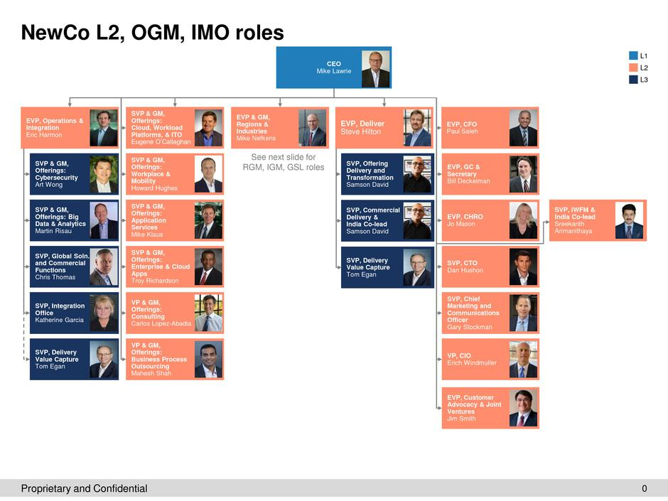

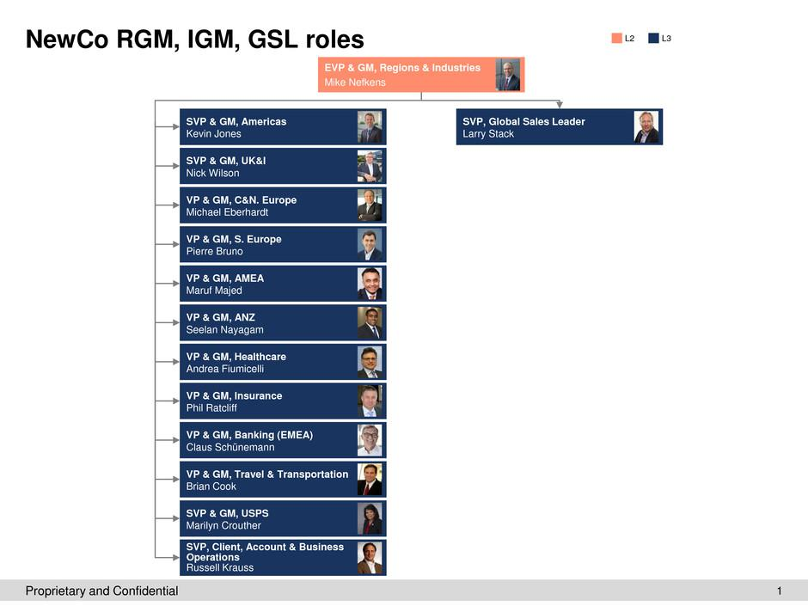

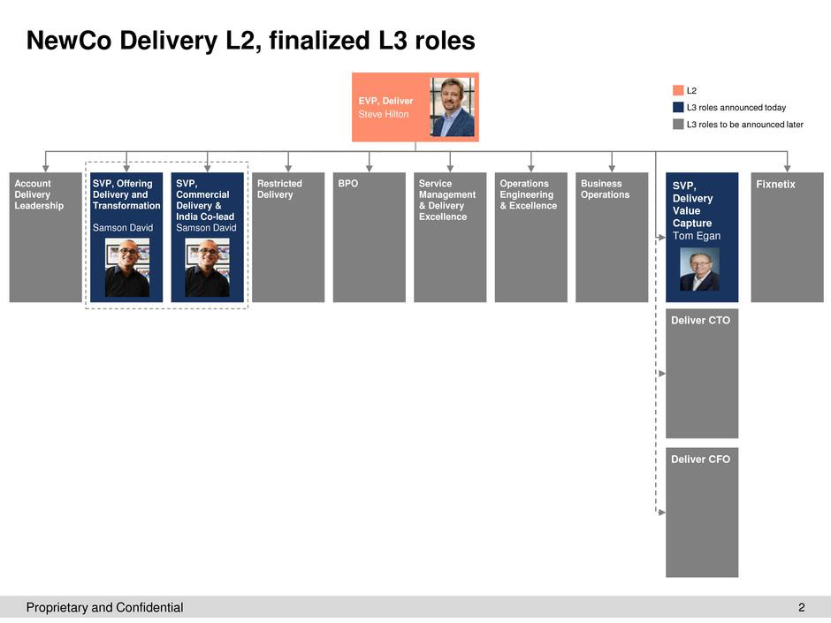

Additional Information and Where to Find It

In connection with the proposed transaction, Everett SpinCo, Inc., a wholly-owned subsidiary of Hewlett Packard Enterprise Company (“HPE”) created for the transaction (“Spinco”), filed with the SEC a registration statement on Form S-4 and a registration statement on Form 10 containing a prospectus-information statement and CSC will file with the SEC a proxy statement on Schedule 14A. INVESTORS AND SECURITY HOLDERS ARE ADVISED TO READ THE REGISTRATION STATEMENTS AND PROSPECTUS-INFORMATION STATEMENT, BECAUSE THEY CONTAIN IMPORTANT INFORMATION ABOUT THE PARTIES AND THE PROPOSED TRANSACTION AND TO READ OTHER DOCUMENTS FILED BY CSC, HPE, AND SPINCO (INCLUDING AMENDMENTS TO EXISTING FILINGS) AS AND WHEN THOSE DOCUMENTS ARE FILED BECAUSE THEY WILL CONTAIN IMPORTANT INFORMATION ABOUT THE PARTIES AND THE PROPOSED TRANSACTION. Investors and security holders may obtain a free copy of these and other documents filed with the SEC by CSC, HPE and Spinco at the SEC’s web site at http://www.sec.gov. Free copies of these documents as well as other documents that will be filed in the future (including amendments to the documents) and each of the companies’ other filings with the SEC, may also be obtained from CSC’s web site at www.csc.com.

This communication is not a solicitation of a proxy from any investor or security holder. However, CSC, HPE, and certain of their respective directors, executive officers and other members of management and employees, may be deemed to be participants in the solicitation of proxies from stockholders of CSC in respect of the proposed transaction under the rules of the SEC. Information regarding CSC’s directors and executive officers is available in CSC’s 2016 Annual Report on Form 10-K filed with the SEC on June 14, 2016, and in its definitive proxy statement for its annual meeting of stockholders filed on June 24, 2016. Information regarding HPE’s directors and executive officers is available in HPE’s 2016 Annual Report on Form 10-K filed with the SEC on December 15,

2016, and in its definitive proxy statement for its annual meeting of stockholders filed on February 12, 2016. These documents as well as other documents filed by CSC, HPE or Spinco with the SEC can be obtained free of charge from the sources indicated above. Other information regarding the participants in the proxy solicitation and a description of their direct and indirect interests, by security holdings or otherwise, will be contained in the registration statements, prospectuses and proxy statement and other relevant materials to be filed with the SEC when they become available.

This communication shall not constitute an offer to sell or the solicitation of an offer to sell or the solicitation of an offer to buy any securities, nor shall there be any sale of securities in any jurisdiction in which such offer, solicitation or sale would be unlawful prior to registration or qualification under the securities laws of any such jurisdiction. No offer of securities shall be made except by means of a prospectus meeting the requirements of Section 10 of the Securities Act of 1933, as amended.

All statements in this press release and in all future press releases that do not directly and exclusively relate to historical facts constitute “forward-looking statements.” Many factors could cause actual results to differ materially from such forward-looking statements with respect to the transaction referred to above including risks relating to the completion of the transaction on anticipated timing, including obtaining shareholder and regulatory approvals, anticipated tax treatment, unforeseen liabilities, future capital expenditures, inability to achieve expected synergies, loss of revenues, delay or business disruption caused by difficulties in integrating the businesses of CSC and Everett as well as the matters described in the “Risk Factors” section of Spinco’s Form S-4 and Form 10, CSC’s most recent Form 10-K and any updating information in subsequent SEC filings. CSC, Spinco and HPE disclaim any intention or obligation to update these forward-looking statements whether as a result of subsequent event or otherwise, except as required by law.

